555 Timer IC
CP031
Image:
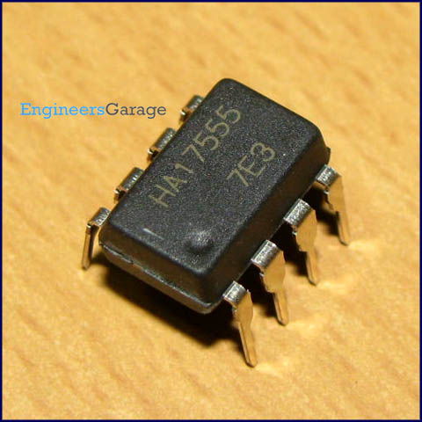
DataSheet:
555.pdf
555 is a very commonly used IC for generating accurate timing pulses. It is an 8pin timer IC and has mainly two modes of operation: monostable and astable. In monostable mode time delay of the pulses can be precisely controlled by an external resistor and a capacitor whereas in astable mode the frequency & duty cycle are controlled by two external resistors and a capacitor. 555 is very commonly used for generating time delays and pulses.

Pin Diagram:
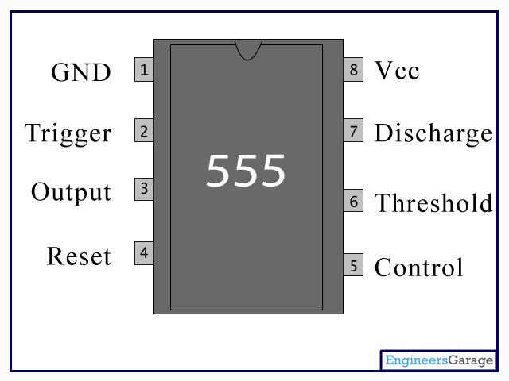
Pin Description:
Pin No | Function | Name
1 | Ground (0V) | Ground
2 | Voltage below 1/3 Vcc to trigger the pulse | Trigger
3 | Pulsating output | Output
4 | Active low; interrupts the timing interval at Output | Reset
5 | Provides access to the internal voltage divider; default 2/3 Vcc | Control Voltage
6 | The pulse ends when the voltage is greater than Control | Threshold
7 | Open collector output; to discharge the capacitor | Discharge
8 | Supply voltage; 5V (4.5V - 16 V) | Vcc

